District Attorney
County of

CA

RE: ,
NSH #
CT #:

Dear District Attorney:

This is to request that a petition for extended commitment be filed in the case of the above individual committed under Penal Code Section 1026. DSH-Napa has good cause to believe that they are a person who by reason of their severe mental disorder qualifies for continued treatment under Penal Code Section 1026.5.

When your office has filed a petition in this case and hearing has been calendared, please email the petition/notice and disposition of hearing along with a certified copy of the Order to DSH-Napa, Attn: Forensic Services – Legal Records via email to NSH.CourtDocuments@dsh.ca.gov or fax to (707) 254-2321.

If it is the decision of your office that the patient does not meet criteria for extension of the commitment and therefore a petition will not be filed with the court, please advise this hospital in writing of such decision so that we may initiate plans for discharge at the end of the commitment term.

The current two-year period of treatment expires on .

Sincerely,
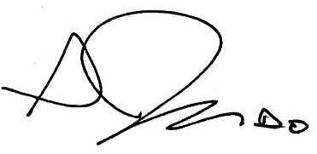
Seth Judd, D.O.
Medical Director, or Designee
4/7/2025
Enclosures
cc:
A F F I D A V I T

I, the Medical Director of DSH-Napa, have legal responsibility for the care and treatment of [Click & type] [Click & type], NSH#[click & type] County Superior Court # [click & type the court number].

I have reviewed the case and it is my opinion that the above-named individual qualifies for continued involuntary treatment under Section 1026, California Penal Code.

Therefore, I am recommending to the prosecuting attorney that application be made to the appropriate court for such continuation of treatment.

I declare under penalty of perjury that the foregoing is true and correct to the best of my knowledge.

Seth Judd, D.O.
Medical Director, or Designee

4/7/2025

